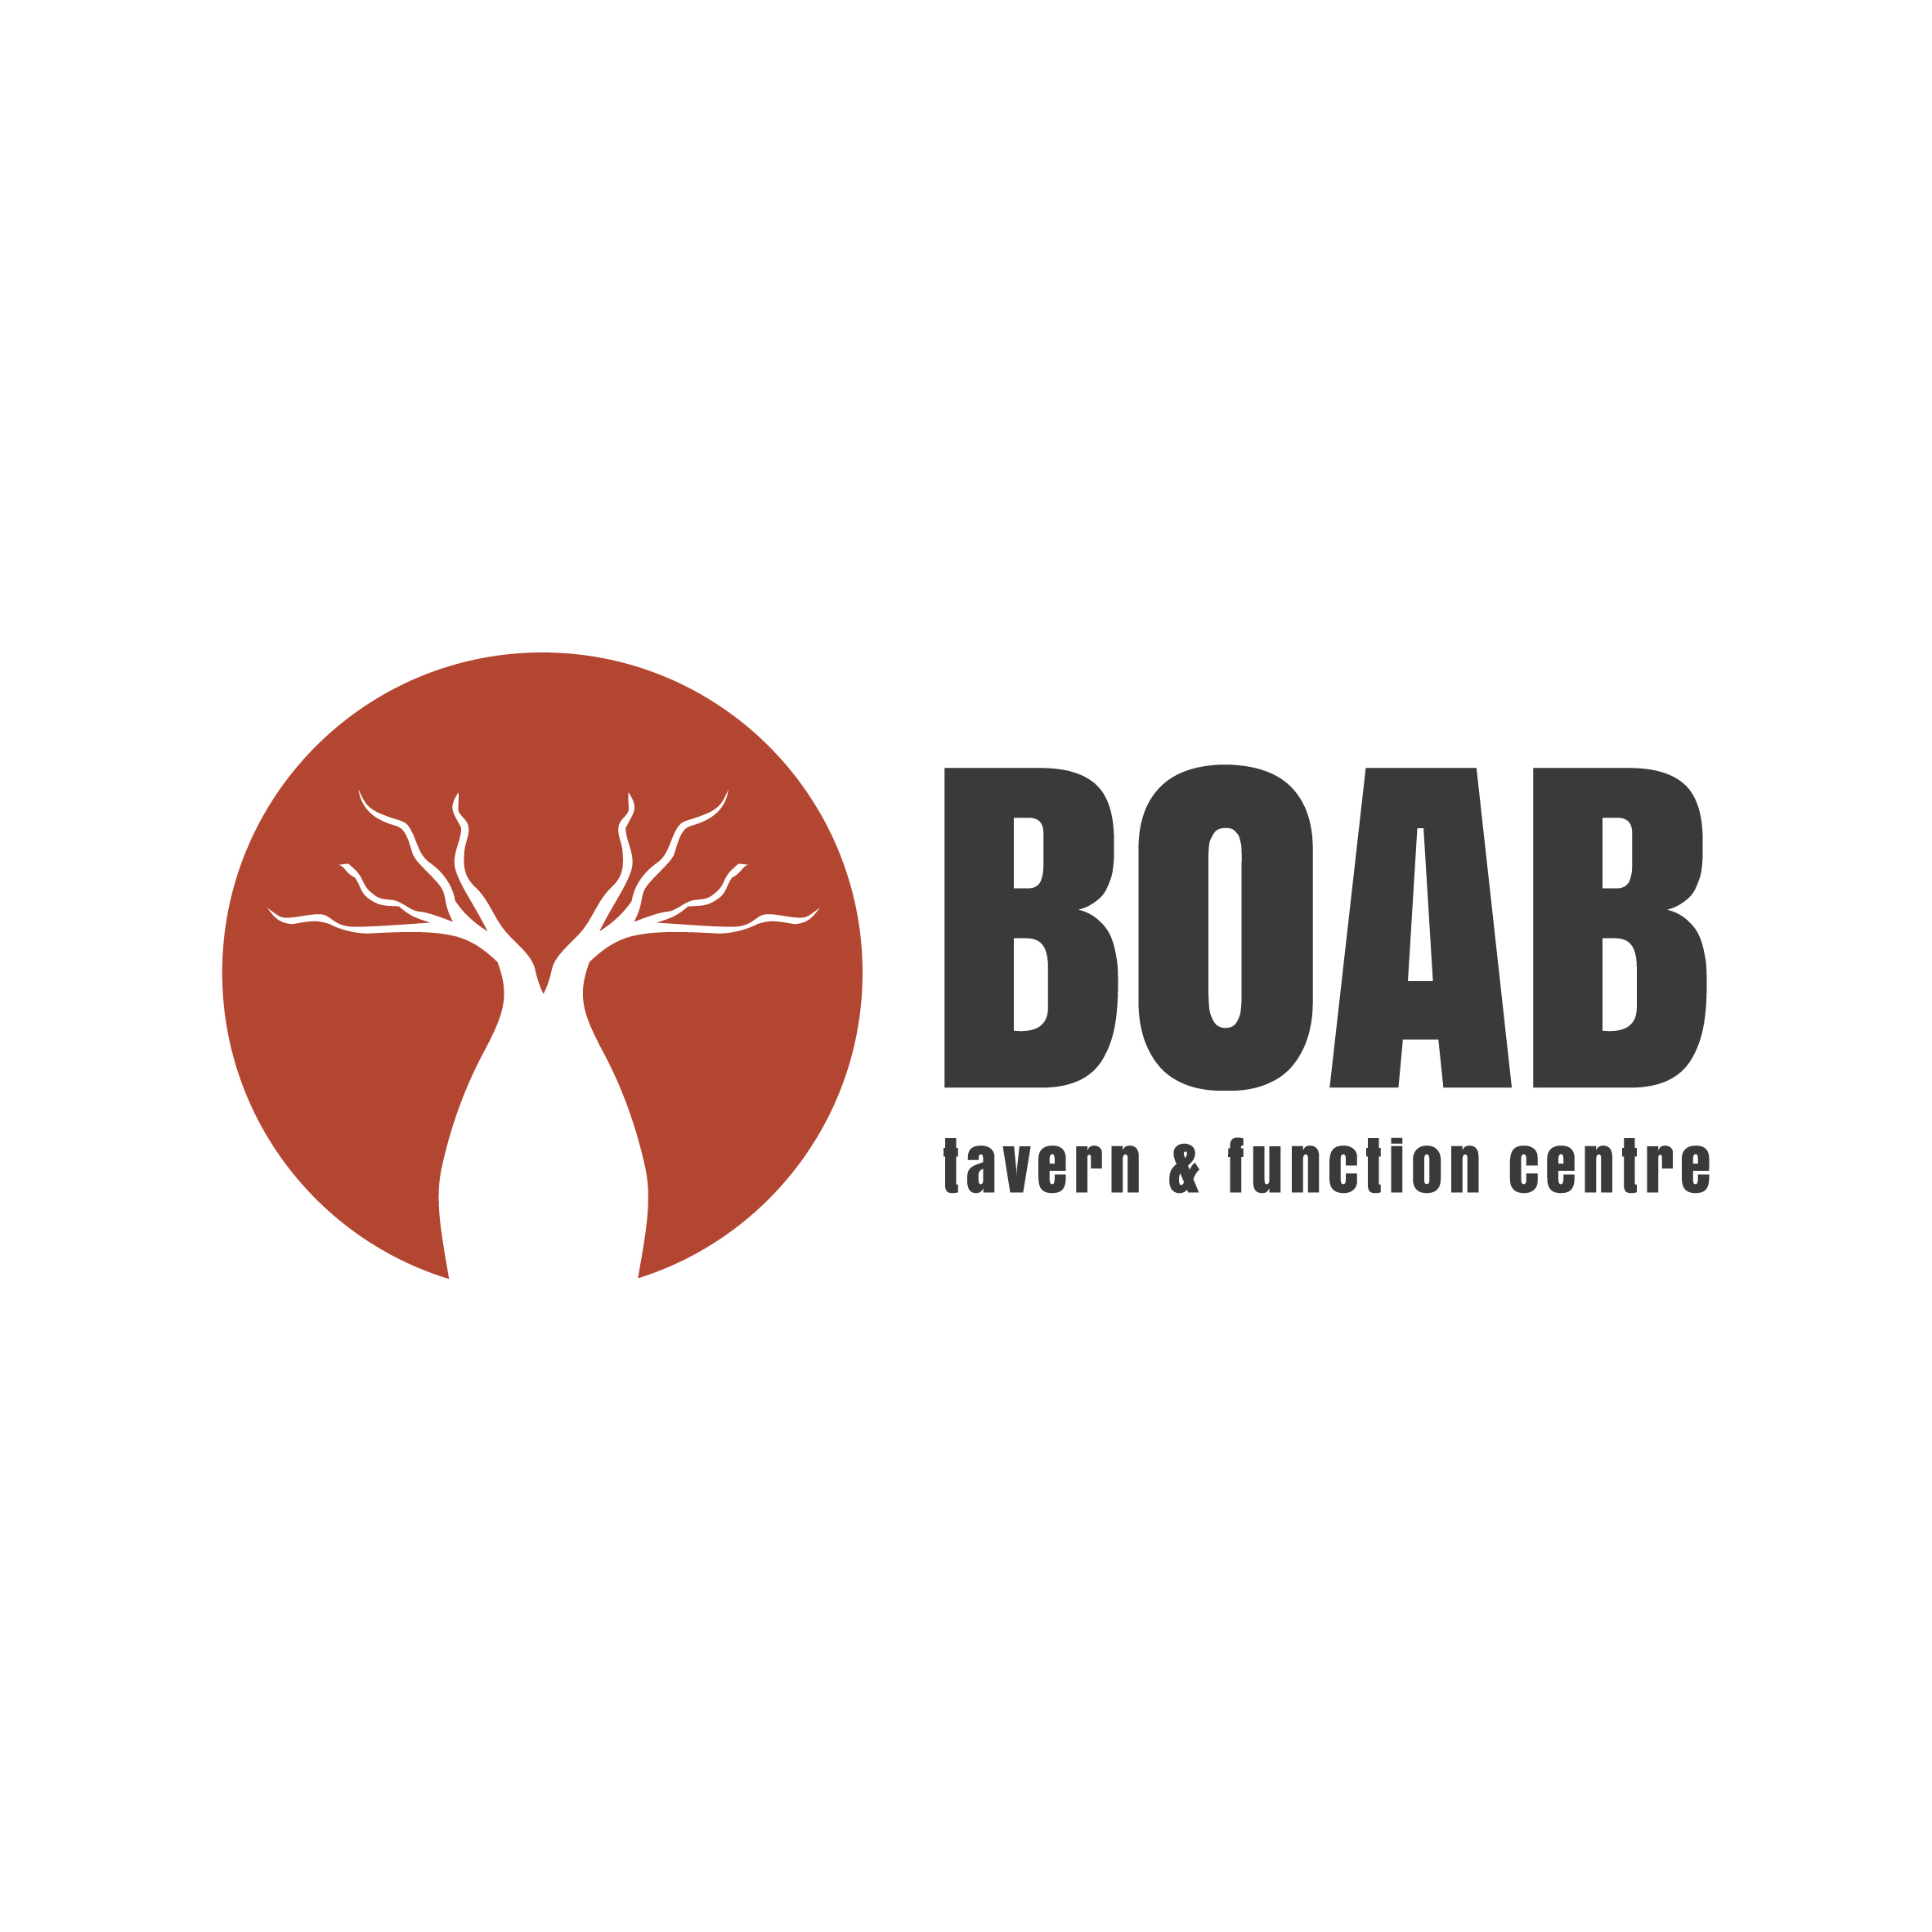

Taking its name from the Australian tree, the Boab is a friendly meeting
place for friends, business associates and the community.

Thank you for expressing interest in the Boab Tavern and Function Centre
for your next function.

The following package is designed to provide you with the basic and necessary information regarding functions at the
Boab Tavern and Function Centre.

If we can be of any further assistance, please do not hesitate to contact us
at the venue at any time.

CONTACT DETAILS

107 Dundas Road, High Wycombe WA, 6057

Phone – (08) 9454 3566

contact@boabtavern.com.au

www.boabtavern.com.au
www.facebook.com/boabtavern

VENUE DETAILS
The Boab Tavern and Function Centre is a newly established state of the art venue south of the river. The Hotel comprises a Bistro, Lounge Bar, Terrace, Function Rooms, Sports Bar, Pub Tab and three beautifully presented Alfresco Areas.

At the Boab Tavern and Function Centre we can cater for many types of functions or parties that include…
- Birthdays
- Engagements
- Weddings
- Business or social club meetings
- Sundowners
- Corporate events
- Training seminars
- …and that’s just to name a few!

Boab Tavern and Function Centre offer a relaxed atmosphere in a myriad of settings and provide quality food and beverage at competitive prices.

Our friendly team here at the Boab Tavern and Function Centre will make every attempt to meet any special requirements you may have for your function… just ask us! We will endeavor to accommodate the needs of you and your guests in every instance.

In preparing for your function, please consider the following questions.
- What type of function do I want? e.g. cocktail, sit down, seminar, etc.
- How many people will I be expecting?
- How much money do I have to spend?
- Do I have any special requirements that need addressing, whether it be food, beverage, audiovisual, room set up, etc.?

We welcome anyone considering a function to come in and view the venue, so that you can get a firsthand look at the rooms and areas available. Either contact the venue and make an appointment, or simply come in and enjoy a drink and a bite to eat while you look around. Alternatively, we have pictures for viewing of our venue and function center on our website. Simply visit www.boabtavern.com.au

DEPOSITS/CHARGES
Confirmation of all functions at Boab Tavern and Function Centre is secured by payment of the room hire fees. Room hires rates vary depending on the room and the type of function you require. A corporate rate for businesses is also available. The room hire covers all staffing expenses along with the setting up and cleaning of the room. Additional fees may occur if your function requires extra team members or other services such as security. The room hire is non-refundable and any damage to the room will incur an extra cost payable on the night. Please note that all deposits are non-refundable should there be a cancellation. However, you can transfer to another date if at least one month’s notice is given from the previous booking date.
Room Hire and Audio-Visual Equipment
- $300 Room Hire for the Bistro courtyard area.
- $300 for the hire of the Sports Bar (Saturday and Sunday night only from 6pm)
- Room Hire for other areas depends on function type and area required.
- Cordless Microphone
In peak periods the room hire price is subject to change.
Deposit
Payment of room hire is considered deposit and will guarantee your date.
Other Areas
Throughout the Tavern there are many other spaces that can be utilized as function areas depending on the style of your function. Room hire rates for these areas can be discussed with our function coordinator upon your enquiry.
Linen
White tablecloths are included in the price. Colored tablecloths are an additional $15.00 per cloth.

FOOD
Boab Tavern and Function Centre is able to cater for and provide a range of food options to suit your dining requirements.
All menus have gluten free and vegetarian options available on request. This must be arranged when food options are finalised. A set menu is available upon request.

Share Platter Menu
All function platters require a minimum 3 business days’ notice.
Wedges with sweet chilli and sour cream $65.00
Party pies $70.00
Sausage rolls $70.00
Calamari Rings $75.00
Crispy chicken strips $75.00
Vegetable spring rolls $75.00
Vegetarian samosas $80.00
Arancini $80.00
Asian style pork bites $90.00
Lamb koftas $90.00
Prosciutto wrapped scallops $95.00

Platters will be served with a selection of dipping sauces.

Mixed Platter Menu

Gluten free platter - chicken tenderloins, prawn skewers, chorizo, $95.00
olives, feta, pickled vegetables, crudites and dips.
Antipasto platter – a selection of cured meats, pickles, vegetables, $95.00
olives, feta, grilled Turkish bread, arancini, olive oil and balsamic glaze.
Trio of cheese platter – three cheeses, crackers, pickles and fresh fruit. $95.00
Vegetarian platter – spring rolls, samosas, pumpkin and feta arancini, $95.00
Sweet chilli sauce and aioli
Chicken platter – crispy chicken strips, hot wings, cajun tenderloins, $110.00
BBQ sauce and cheesy mayo.

Party platter – mini pies, sausage rolls, quiches, $110.00
tomato sauce and aioli.
Seafood platter – prawn and scallop skewers, $130.00
salt and pepper calamari, fried fish goujons and tartare sauce.

Substantial Platter Menu

15 pieces per platter

Chicken sliders with chipotle mayo and slaw. $95.00

Cheeseburger sliders with pickles and mustard. $95.00

Battered fish and chip boxes with tartare sauce and lemon. $110.00

BEVERAGE SELECTION

Available for your function is an extensive range of beverages including bottled and draught beers, wines premixed drinks, spirits and soft drinks. Due to Responsible Service of Alcohol laws and restrictions The Boab Tavern and Function Centre is unable to offer any discount beverages. All drinks are charged on a consumption basis with the choice of unlimited or limited bar tabs designed to suit your budget and function, as well as “pay as you go” arrangements. (i.e. normal bar service)

All beverages are subject to change
ON TAP
- Carlton Draught
- Carlton Dry
- Great Northern Ginger Beer
- Asahi
- Pirate life pale ale 3.5
- Victoria Bitter
- Bulmers Cider
- Pirate Life South Coast
- Great Northern Original
- Great Northern Super Crisp
- Guiness
- Matilda bay hazy larger
- Single Fin
- Alby
- Hard Solo
- Alcoholic lemonade

A full range of bottled beers, wines and premix drinks are available on request. Ask our function coordinator and we will endeavor to cater for your specific requirements.


TERMS & CONDITIONS

Office of Racing, Gaming & Liquor and the Boab Tavern and Function Centre House Management Policy
1.1 Only beverages purchased on the premises may be consumed on these premises. You are not permitted to bring beverages on the property, nor consume beverages purchased through our on-site retail outlet.
  - No food may be brought on site without the prior consent of the Venue Manager.

  - In order to comply with our in house Responsible Service of Alcohol standards, it is a requirement that a minimum order of 1platter per 15 guests are purchased with any function booked in the Venue except in the case where a buffet or set menu has been booked.

1.4 Food & beverages purchased at the Boab Tavern and Function Centre are strictly for consumption on the premises. No food or beverage may be taken home for consumption.
1.5 Boab Tavern and Function Centre and its staff are responsible servers of alcohol. If, in the opinion of the venue, you or any of your guests are deemed to be intoxicated, argumentative and/or aggressive, they can be refused service and/or asked to leave the venue immediately.
1.6 All persons attending the venue must be able to provide adequate identification or proof of age on request at any time. A current passport, proof of age card or Australian drivers license is the only acceptable form of identification in Western Australia.
  - Boab Tavern and Function Centre has conditions in our hotel tavern license that prohibits anyone to be immodestly or indecently dressed, take part in, undertake or perform any activity or entertainment on licensed premises that is of a lewd or indecent manner. This includes ‘R’ rated moving pictures, contractors, employees or any patrons. Any breach of this condition will result in the immediate conclusion of the event/function and no refunds of room hire, foods or beverage will be applicable. The below credit card will be charged for any outstanding monies. All guests of our venue including functions are to wear neat casual attire. This prohibits thongs, singlet’s, hooded jumpers, work wear hats or beanies.

  - Due to licensing requirement the bar will close at 11:45pm and no later.

2. Deposit and Payment Policy
2.1 Confirmation of your booking will be deemed complete upon the return of a signed copy of the Terms & Conditions along with a valid credit card number, or cash deposit. Tentative bookings will be held for 10 days.
2.2 Payment in full is required prior to the completion of the function. Cash and all credit cards are accepted. Unfortunately we do not accept cheques.
2.3 You, the undersigned, will be deemed responsible and held liable for the costs of repairs for any damage caused by yourself or your guests during the function.
3. Cancellation Policy
  - Whilst we would share in your disappointment if your function was cancelled, all cancellations will result in your function deposit being held. All function deposits once paid are non-refundable; however, it is transferable to another date if at least 1 months’ notice is given to the previous booked date.

- Smoking Policy

  - The Boab Tavern and Function Centre has allocated smoking areas we ask you kindly to please abide by these.

- Best Service Policy

  - The Boab Tavern and Function Centre will endeavor to provide your required services, contingent on being able to do so. We will not
accept any liability in the case of business interruption, including, not but limited to, labor disputes, major mechanical failure or any other circumstances that may inhibit the trading capacity of the venue.

Signature_________________________________________ Phone_____________________________________
Name_____________________________________________ Date______________________________________
Date of Function_______________________ Function Area __________________ Function Start Time_________

Credit Card Type: Visa MasterCard Amex Diners

Card Number:

__ __ __ __ __ __ __ __ __ __ __ __ __ __ __ __

Expiry Date: CVV:

__ __ / __ __ __ __ __

Card Holders Name: ____________________________ Card Holders Signature: _______________________

